|  |
| --- |
| EXERCISES |
|

**TASK # 01**

Create a replica of EMP table with all the records in it.

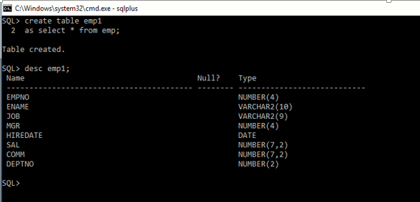

**TASK # 02**

Add a column ‘Address’ in it.

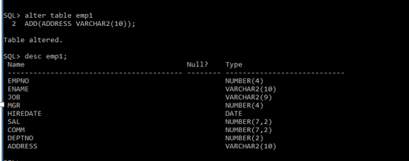

**TASK # 03**

Drop column ‘Address’ from it.

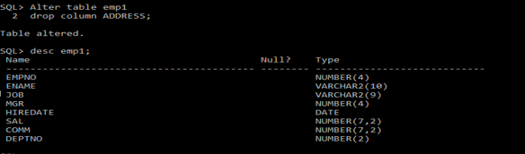

**TASK # 04**

Add columns ‘House No’ character ,’Street No’ numeric, ’Area’ character ,’City’ character in it with the respective data types.

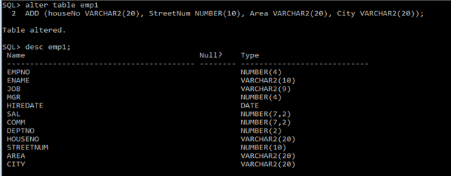

**TASK # 05**

Change the data type of ‘House No’ from character to numeric.

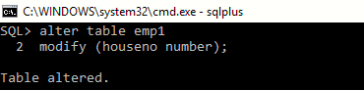

**Task # 06**

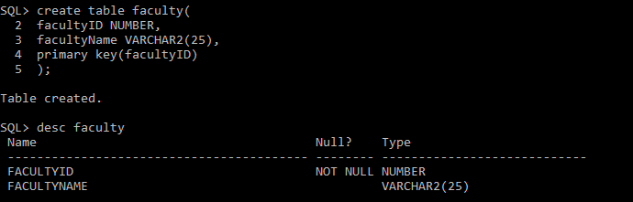

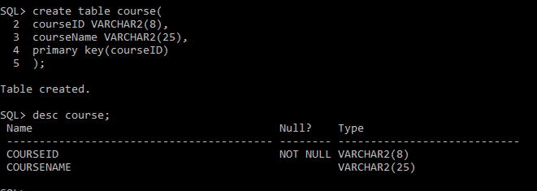

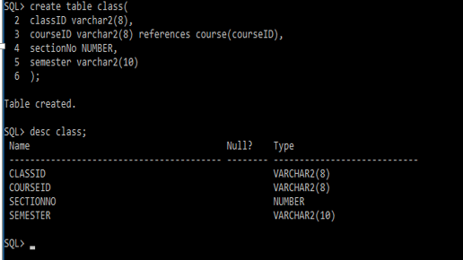

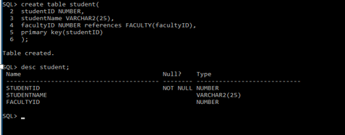

**TASK # 07**

How would you add an attribute, CLASS, to the STUDENT table?

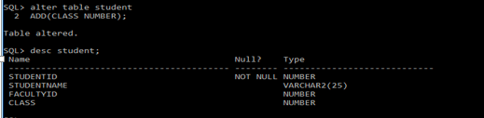

**TASK # 08**

How would you remove the FACULTY and STUDENT tables?

